Importance of spores

Biological:

a. Insure survival because of dormancy qualities
b. Allow for dissemination of fungus to new substrates
c. Allow for reproductive multiplication of the hyphal fungus
d. Allow for the establishment of new individuals with genetic potentials different than parents

Practical:

a. Allow for "rapid" identification
b. Sources of infection of plants, animals, etc.
c. Sources of contamination
88

Fungal spore types

1. Endogenous mitospores* -zoospores and sporangiospores of fungal-like protists and zygomycota
2. Exogenous mitospores* - conidia, blastospores, teliospores**, etc. of ascomycota, basidiomycota, z fungi imperfecti
3. Endogenous meiospores+ -ascospores of ascomycota
4. Exogenous meiospores+ -basidiospores of basidiomycota
5. Karyospores+ - zygospores, oospores, resting spores and resting sporangia of zygomycota, oomycota & chytridiomycota respectively
6. Chlamydospores* - vegetative units that attain spore-like characteristics (dormancy qualities).

* asexual + sexual
** N+N
89

Generalized fungal life cycle

1. Period of vegetative growth (colonization and substrate exploitation)

2. Period of asexual reproduction (often called anamorphic* phase of fungal life cycle)

3. Period of sexual reproduction (often called the teleomorphic phase of fungal life cycle)

* Often the most common name of a fungus is its anamorphic name (because discovered and/or observed first)
90

Taxonomic systems for identification of the anamorphs of conidiogenous fungi

- The Saccardo System ~ 1880s
identification based totally on final morphology of conidium

- *Vuillemin ~ 1910
concept of thallospores & conidia

- The Hughes-Tubaki-Barron system ~1968+
based primarily on mechanism of conidium development

- Ellis (Cole, Kendrick & Sampson)_Systems ~1971+
based on both mechanisms of conidium & conidiophore development (mod. of #3)

98

Types of conidia

Thallic = conidia produced by the conversion of a pre-existing hypha, which may or may not freely disarticulate

Blastic = conidia which are produced by blastic outgrowth that is similar to yeast budding.
8-2/99

Conidial types per Hughes-Tubacki-Barron and per Ellis

Thallic conidia
Holothallic
1. Aleuroconidia
Holoarthric and enteroarthric
2. Arthroconidia

Blastic conidia
Holoblastic
3. Blastoconidia
4. Botryoblastoconidia
5. Poroconidia
6. Sympoduloconidia

Enteroblastic
7. Phialoconidia
8. Annelloconidia
101

Thallic conidia

1. Arthroconidia 2. Meristem arthroconidia

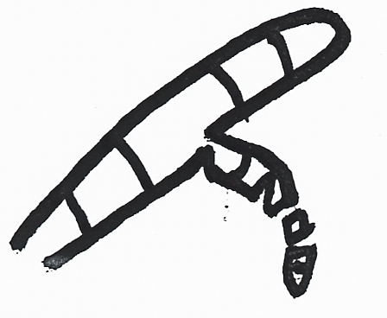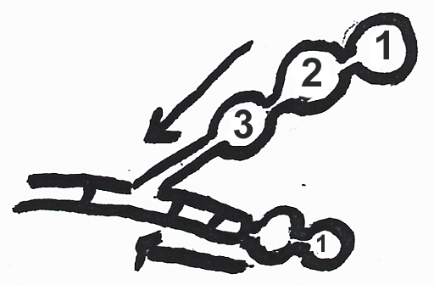

geotrichum oidiodendren
random separation- basipitalous formation

3. Aleurioconidia (Holothallic)

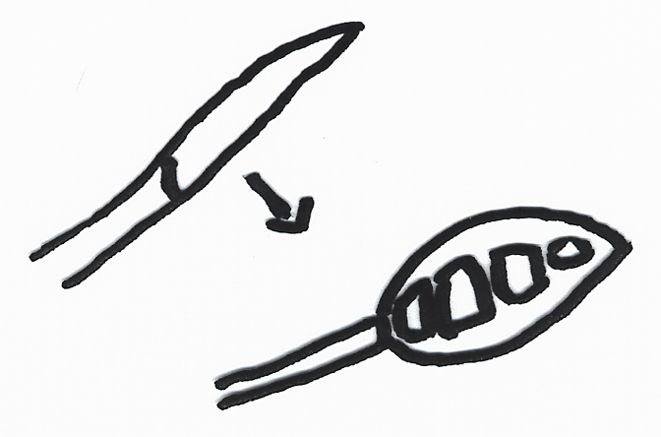

microsporum
8-10/111

Blastic conidia
4. Annelloconidia

Annellations  (annellidic)  Basipetalous &  (Enteroblastic) | 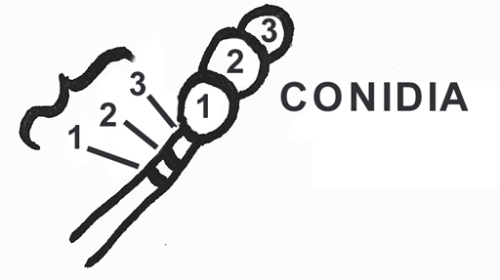  Scopulariopsis  Exophiala

Scopulariopsis Exophiala

- Blastoconidium

Cladosporium | 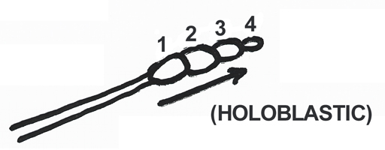
Acropetalous

6. Botryoblastoconidia

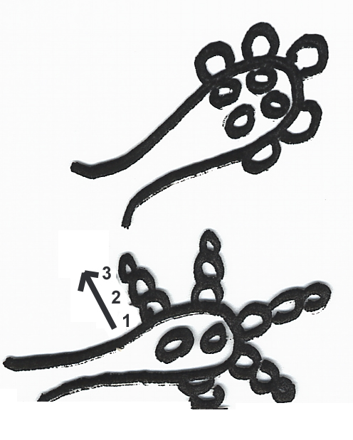 | Oedocephalum  Sometimes produce  secondary acropetalus  conidia  (Holoblastic)
Superficially looks like Aspergillus
8-11/112

7. Poroconidia

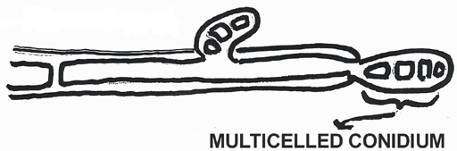

Helminthosporium
(Holoblastic)

8. Sympoduloconidium

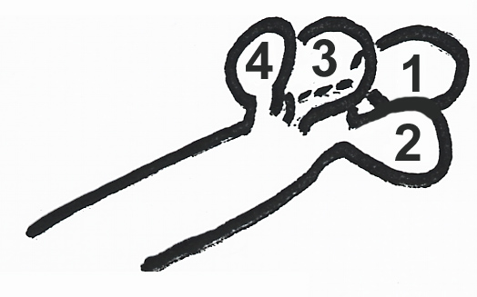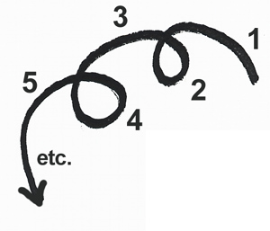

Fusicladium (Holoblastic)

9. Phialoconidia

produced enteroblastically from phialids
Penicillium
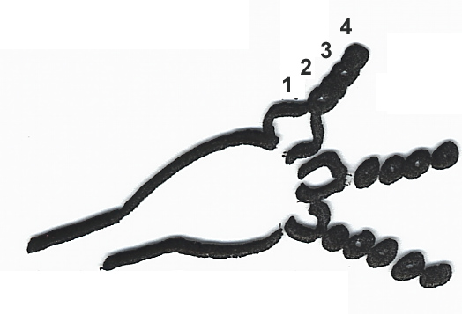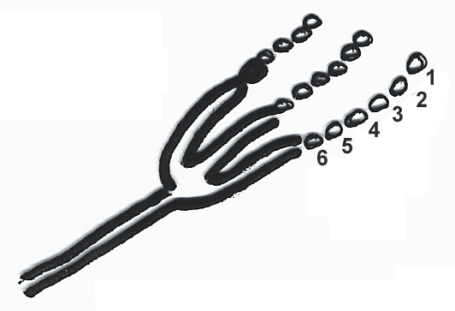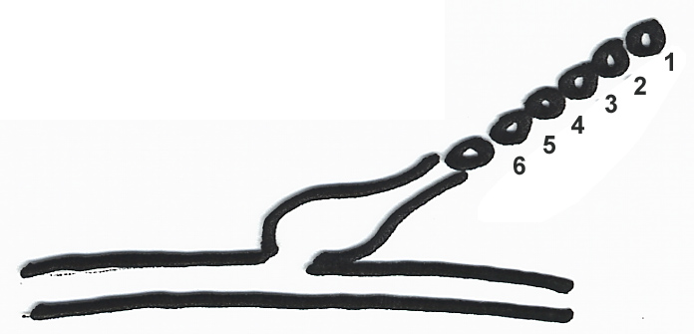

Aspergillus Phialophora
(Phialidic)
8-12/113

