About "Fungal" Thalli- a review:
Fungi characterized by a distinctive, multinucleate, vegetative
(somatic) thallus (body) called
the mycelium (singular)
mycelia (plural)
The mycelium consists of a branching system of walled tubes called
hyphae (plural)
hypha (singular)
Mechanisms of hyphal growth* are
apical extension & lateral branching.
* non reproductive growth
Not only unit of structure, as many fungi and fungal-like protists
are nonhyphal organisms
Better to refer to vegetative body of a fungus as a thallus

Thallus types
Holocarpic vs Eucarpic
A. Holocarpic (Holocarpism)
Whole thallus of fungus becomes converted into a reproductive cell*
Found among:
1. Chytridiomycota
2. Hyphochytridiomycota
3. Plasmodiophoromycota
4. Oomycota
5. Ascomycota
6. Basidiomycota**
7. Fungi imperfecti
* "simplest thalli"
** if stretch definition 64

a. S. cereviseae - Hemiascomycotina
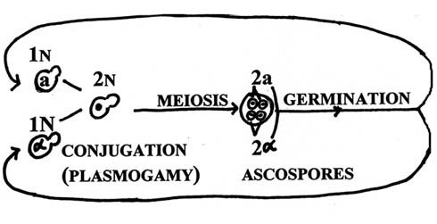
b. Synchytrium - Chytridiomycota
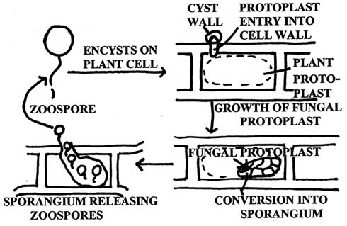
65

Eucarpic (Eucarpism) Thallus
- differentiates into distinct vegetative and reproductive portions
- found among all divisions
trends to complexity (hyphal construction)
1. Monocentric (monocentrism)
Thallus consists of single reproductive cell attached to
substrate hyphae
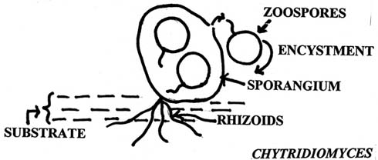
Chytridiomycota
Oomycota
Hyphochytridiomycota

2. Polycentric (polycentrism)*
Thallus has many reproductive centers**
Simplest or at least step above Chytridiomyces might be Nowakowskiella***
Extensive rhizoidal system with many sporangia
* most "fungi" eucarpic & polycentric
* all groups except plasmodiophoro-mycota
*** Chytridiomycota 67/69
Blastocladiella*

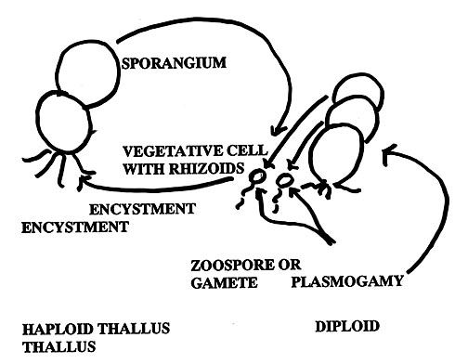

*Chytridiomycota
70
Hyphal "fungi" (obvious hyphae) found among:

Septation Trends
Tend to be coenocytic* | 1. Chytridiomycota
Tend to be coenocytic* | 2. Oomycota
Tend to be coenocytic or irregularly septate | 3. Zygomycota
Tend to be regularly septate | 4. Ascomycota  Hemiascomycotina  Euascomycotina
Tend to be regularly septate | 5. Basidiomycota  Heterobasidiomycotina  Homobasidiomycotina
Tend to be regularly septate | 6. Fungi Imperfecti  Hyphomycetes  Coelomycetes  Mycelia Sterilia

* coenocytic/coenocynism = growth and nuclear division w/o cytokinesis
73

Septal conditions in "fungi"*

Fungal-like protists and Chytridiomycota | tend to be aseptate except to delimit reproductive cells (e.g. sporangia, gametagia)  septa when formed "complete" (no pores)
Zygomycota | tend to be aseptate or have septa formed at irregular intervals in their hyphae (septa when formed "complete")
Ascomycota & basidiomycota yeasts | tend to form complete septa or micropore septa between mother and daughter cells
* Fungi includes fungal-like protists and Chytridiomycota
74

Septa of hyphal Ascomycota and Basidiomycota

Ascomycota | tend to form hyphal septa at regular intervals  septa are "simple septa" with a central septal pore & Woronin bodies
Basidiomycota | tend to form hyphal septa at regular intervals  septa are "dolipore" or "pulley wheel" type with central pore, parthenosome membranes or pulley wheel plug.
77

Review - "fungal" thalli/thallus

Appear to be trends in fungal vegetative and reproductive structure (thallus) from simple --> complex -->(?) simple. These may be evolutionary trends.

Holocarpic - whole vegetative thallus converted to reproductive center

Eucarpic - separation of vegetative &reproductive function
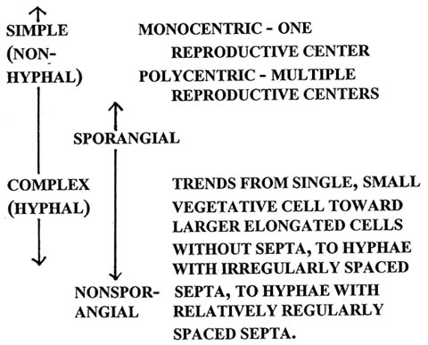
79

"Fungal" nuclear conditions

1. Most nonyeast "fungi" multinucleate, whereas most "yeasts" uninucleate

2. Among fungi there are haploids and diploids
a. Majority of "fungi" vegetative haploids
b. Oomycota vegetatively diploid
c. Some "fungi" alternate haploid and diploid phases
d. Some members of predominantly haploid groups are vegetatively diploid

Haploidy = 1 set of chromosomes per nucleus
Diploidy = 2 sets of chromosomes per nucleus

3. Terms associated with genetics of multinucleate "fungi"
a. Homokaryotic/homokaryons
b. Heterokayotic/heterokaryons
c. Monokaryotic/monokaryons
d. Dikaryotic/dikaryons
5-17/6-3

Nuclear conditions related to multinucleate states of fungi

1. Homokaryons - multinucleate forms with all nuclei genetically identical [or at least identical with regard to gene(s) in question]

2. Heterokaryons - multinucleate forms with genetically different nuclei coexisting in the same cytoplasm

3. Dikaryons - specialized heterokaryons in which nuclei having different mating-type gene(s) co-existing in the same cytoplasm

4. Monokaryons - homokaryons or heterokaryons having only one mating-type gene(s) set.

5. Exact perpetuation of the dikaryotic condition occurs in some higher fungi.

a. In many Euascomycotina by crozier formation*

b. In some Heterobasidiomycotina and some Homobasidiomycotina by clamp formation **

*immediately prior to ascus production.

**during normal hyphal growth of dikaryons.
79/81b

Differences between:

homokaryons and heterokaryons
vs
homozygotes and heterozygotes

Former usually refer to haploid condition, whereas latter to the diploid condition*

Phenotypic results could be the same.

Dikaryotic condition very unique because usually opposite mating type nuclei fuse.

*However could refer to diploids too.
80

Uninucleates vs multinucleates

1. Uninucleates

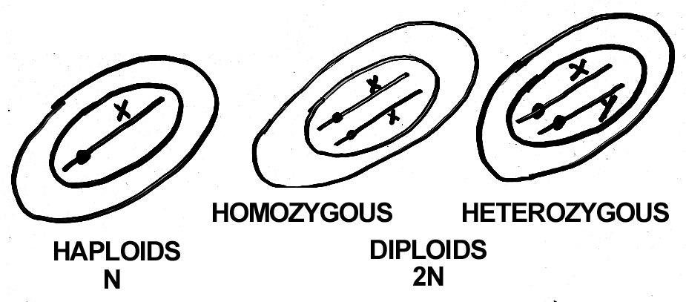

2. Multinucleates (haploid nuclei)

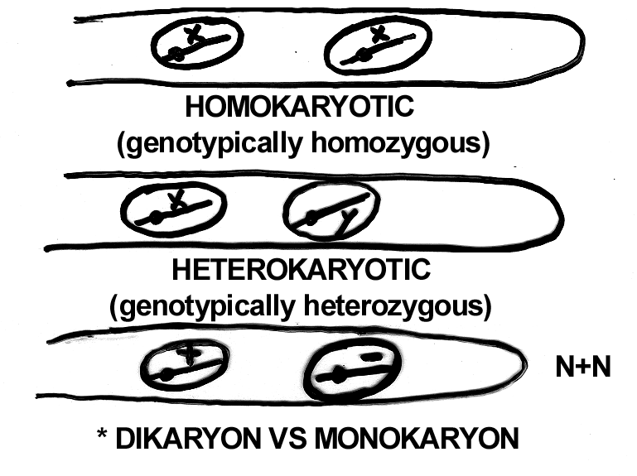
81a

Review - ploidy and nuclear conditions in fungi

1. Majority of fungi are vegetatively haploid, but some are vegetatively diploid totally or in part.

2. Majority of fungi are vegetatively multinucleate in total or in part, but some are vegetatively uninucleate.

3. Multinucleate fungi with genetically identical nuclei are homokaryons, whereas those with genetically different nuclei are heterokaryons.

4. Multinucleate fungi with opposite mating-type nuclei are dikaryons.

5. Exact perpetuation of the dikaryotic condition occurs in some higher fungi.

a. in many euascomycotina by crozier formation*

b. in some heterobasidiomycotina and some homobasidiomycotina by clamp formation**

*immediately prior to ascus production.

**during normal hyphal growth of dikaryons.

