Discussion Points; Pathania et al. (2002). Cell 109: 425-436.
I. What is the aim of the paper?
As we discussed in class, the phage Mu transposes by a replicative mechanism. This is the way the phage multiplies during its lytic cycle. The transposition reaction is mediated by the phage transposase MuA, which recognizes the ends of the Mu genome. We can call these left and right ends, L and R, respectively. The transposition also requires an ‘enhancer’ sequence located within the Mu genome. We shall refer to the enhancer as E. Phage Mu transposition also requires another accessory protein coded for by Mu called MuB. The bacterial protein HU also contributes to transposition. The transposition reaction requires negative supercoiling. In assays in vitro, negatively supercoiled plasmid substrates are employed.
The aim of this paper is to find out the topology of the interaction of the three sites L, R and E when they are brought together within the transposition complex by interactions mediated by the transposase MuA. Or, what is the path of the DNA sites L, R and E within the ‘transpososome’ (the DNA protein machine that catalyzes the chemistry of strand cutting and joining)?
II. How can we define the topology of the transposition complex?
As we noted in class, we can use Flp or Cre recombination to ‘tie off shoe laces in DNA’ such that interdomainal DNA crossings (that we represented in class and in our figures as red x blue crossings) resulting from an adjacent DNA-protein assembly can be trapped. These crossings can be counted as knot or catenane crossings by analytical tools, gel electrophoresis and electron microscopy. When the Flp (or Cre) recombination sites are in head-to-head orientation, the result of recombination is DNA inversion. Depending on the outside red x blue crossings, the product of inversion can be unknotted or knotted. Remember that a single crossing cannot produce a knot. It takes a minimum of three crossings to produce the simplest knot. When there are 3, 5, 7 crossings, the inversion products will be 3-, 5-, 7-knot etc. When the recombination sites are in head-to-tail orientation, the product of recombination will be two deletion circles. When there are no crossings outside, the deletion circles will be unlinked from each other. When there are 2, 4, 6 crossings outside, the deletion circles will form 2-, 4-, 6-catenane etc.
To derive the topology of the transposition complex, we need to find out how many times does E cross L; how many times does E cross R and how many times does L cross R.
The logic of the analysis is the following. To find out the number of crossings between any two sites A and B, we will separate the sites into individual DNA domains, red and blue. This is done by placing the Flp or Cre recombination sites at the domain borders. The points of DNA exchange between the recombination sites precisely define the domain boundaries. We have now site A in domain red and site B in domain blue. We will also make sure that the recombination sites are quite close to site A and on either side of it, say within 100 to 150 bp from the ends of A. The reason for doing this is to avoid random supercoils being trapped by thermal fluctuations during the recombination reaction. In other words, we want to make sure that the crossings we are getting are truly the result of A and B interactions. Thus, for practical purposes, the site A essentially constitutes all of the red domain, and site blue resides within the blue domain.
[Note that one could also place a recombination site close to one end of site A and the second site close to the far end of B, such that A is in the red domain and B is in the blue domain. This will also prevent supercoils other than those resulting from A-B interactions being accidentally trapped during recombination.]
We will be doing our reactions in negatively supercoiled circular plasmids. For each assay, we will have two matched plasmids. One plasmid has the recombination sites in the head-to-head orientation and the other has the sites in the head-to-tail orientation. We can call them inversion and deletion substrates, respectively. When Flp or Cre carries out recombination, the recombinase protein will arrange the sites in antiparallel geometry. Both the inversion and deletion reactions are carried out with sites arranged in this geometry. Recall that it is not the local geometry of sites (parallel or antiparallel) but their global orientation in the plasmid DNA (head-to-head or head-to-tail) that determines the recombination outcome: DNA inversion or deletion.
DNA inversion from antiparallel synapse:
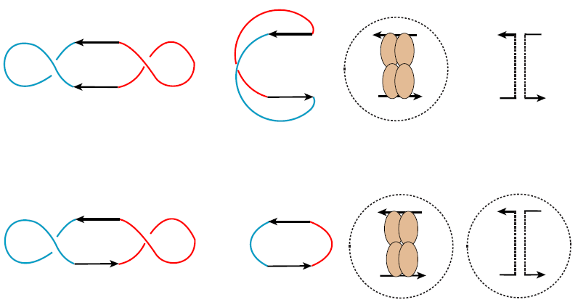
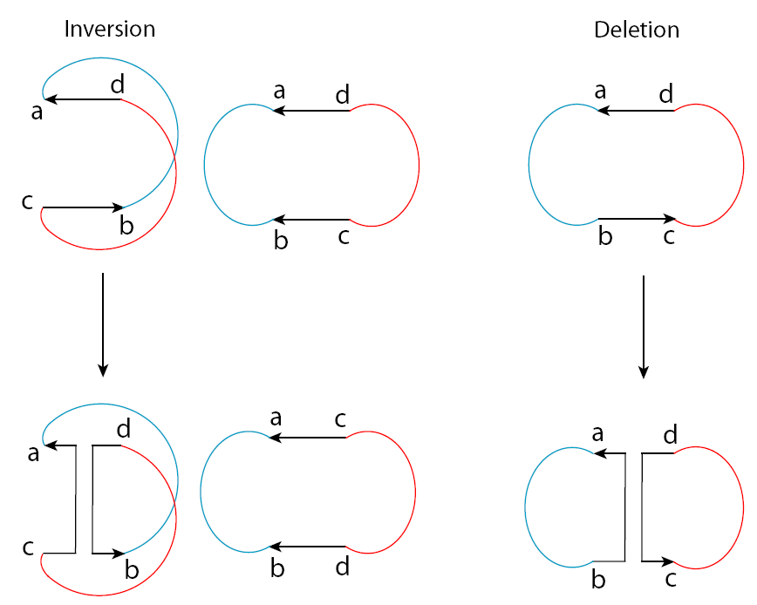

DNA deletion from antiparallel synapse

We will assemble the A-B interactions with the appropriate protein or proteins in the inversion and deletion substrates. Then we will do the recombination reaction with Flp (or Cre) in each case. We will count the crossings in the inversion product (0 crossing means an unknotted product; knots will contain 3, 5, 7 etc. crossings) and in deletion product (zero crossing means unlinked circles; catenanes will contain 2, 4, 6 etc. crossings).
The expectation is that the knot product of inversion and the catenane product of deletion will differ by one if A and B interactions trap a specific number of supercoil crossings between the two. This is because in one case, either the inversion or the deletion substrate, these crossings will bring the recombination sites in the antiparallel geometry, so recombination by Flp or Cre can readily occur. In the other case, the sites will be in parallel geometry. Hence the recombinase will have to trap one more supercoil from the plasmid to arrange them in antiparallel geometry. The same geometry can also be achieved by trapping 3, 5 or 7 additioal crossings. But trapping additional supercoils are energetically costly because of the way we placed our recombination sites very close to the ends of A.
Thus, if we get a 2-catenane for deletion and a 3-knot for inversion, we can say that the sites A and B trap two supercoil crossings. This will bring the deletion sites in antiparallel geometry, and recombination will give the 2-catenane. In the inversion substrate, one more supercoil must be trapped to get them in antiparallel geometry, so the inversion product will be a 3-knot.
III. An example of an external synapse with three negative supercoil crossings
Diagrammed below is the example of a two site interaction that traps three negative supercoils. The result of Flp or Cre recombination in this case will be as follows. The inversion substrate will give a 3-knot. The deletion substrate will give a 4-catenane. Here we have to trap an extra crossing to bring the head-to-tail sites in antiparallel geometry. Hence the deletion catenane has one more crossing than the inversion knot. The smaller number, three, gives the number of the outside crossings, that is, the crossings between sites A and B.

IV. A simplified summary of the paper
First, the sites L and R together were placed in the red domain, and E in the blue domain. The inversion product of Cre recombination after assembling the E x (L-R) crossings with Mu A was a 3-knot. The corresponding deletion product was a 4-catenane.
HENCE ‘E’ MUST MAKE 3 CROSSINGS WITH ‘L’ AND ‘R’ COMBINED. [3 and 4 differ by one, and 3 is the smaller number.]

Second E was placed in one domain (say, red) and R in the other (say, blue). After assembling the E-R crossings with MuA, the inversion product was a 3-knot and the deletion product was a 2-catenane.
HENCE ‘E’ MUST MAKE 2 CROSSINGS WITH ‘R’. [2 and 3 differ by one, and 2 is the smaller number.]
We cannot do a similar experiment with E and L, since R is essential to initiate the assembly of the transpososome.

Third, we separated L and R into red and blue domains. We could do this because it is possible to supply the enhancer as a linear piece of DNA in excess and get MuA to assemble the transpososome. After assembling the L-R crossings with MuA, recombination yielded the 2-catenane for deletion and the 3-knot for inversion.
HENCE ‘L’ MUST MAKE 2 CROSSINGS WITH ‘R’. [2 and 3 differ by one, and 2 is the smaller number.]
The overall results are:
- E makes three crossings with L and R combined.
- E makes two crossings with R.
- Therefore, E makes one crossing with L.
- L makes two crossings with R.
We have all the data to draw the DNA path formed by, E-R, E-L and L-R crossings in the negatively supercoiled plasmid DNA.

