BIO344 Quiz #1
1. What is the most appropriate name for this molecule? :
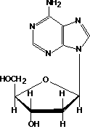
2-deoxycytidine
2-deoxycytidine 5' triphosphate.
2-deoxyguanosine
2-deoxyadenosine
2'-deoxyadenosine 5' triphosphate

2. What is the proper name of this molecule?
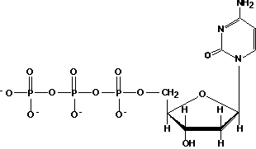
2-deoxycytidine
2-deoxycytidine 5' triphosphate.
2-deoxyguanosine
2-deoxyadenosine
2'-deoxyadenosine 5' triphosphate
3.In the experiment detailed in class that involved using ¹⁵N and ³²P, please answer the following questions.
a)What is the purpose for using ¹⁵N?
the heavy isotope allows for the separation of newly synthesized strands by centrifugation
b)What is the purpose of using ³²P?
The p32 allows for us to follow the label in the second round of replication
c)Why must the cells be synchronized?
So that all replication is taking place at the origins
d)Why must the DNA be sheared?
In order to separate labeled and unlabeled parts of the molecule
e)Why do we see approximately 50% of the ³²P incorporated into the fraction with ¹⁵N?
because there are two strands, only one of which is labeled.

4.What does term processivity mean in terms of DNA replication?
The ability of the polymerase to stay on the DNA template and replicate.

