Bio 350M/388M Plant Molecular Biology Fall 2004, Exam 2
October 14, 2004

Name __________________________________. Answer all questions on this test. Circle the single best, all-encompassing answer for questions 3-14.

- (10 pts) Put labels on the indicated parts of the picture:

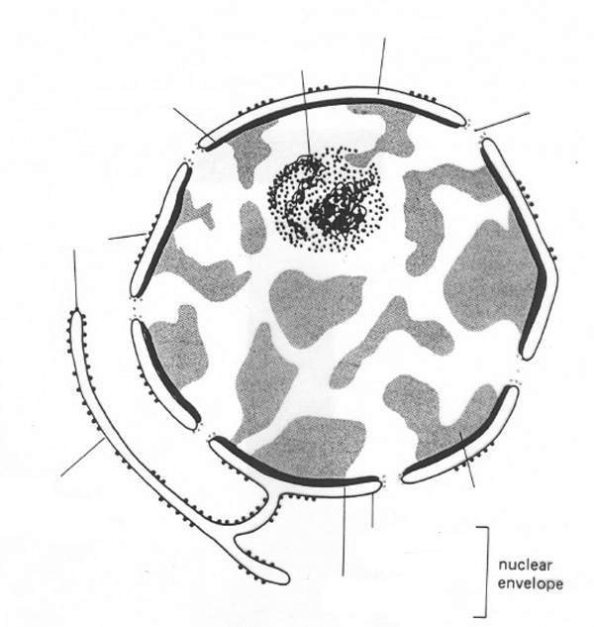

2. (25 pts) Define or describe the following:

SAR –

Euchromatin –

Footprint –

Ac/Ds –

Transposase –

RecA/Rad51 -

NHEJ –

Crown Gall –

Opine -

Electroporation –

3. About how many nuclear genes does Arabidopsis have?
a. about 100,000
b. about 13,000
c. about three times that of E. coli
d. about 8,000 less than humans
4. Which of the following contributes significantly to variation in nuclear genome size among plants.
a. amounts of highly repetitive DNA
b. amount of selfish DNA (e.g., such as transposons)
c. frequency of introns
d. a and b
e. all of the above
5. Which of the following is incorrect concerning the Spm/En element
a. encodes one major protein (the transposase)
b. contains 13-bp inverted repeat at the termini (TIR)
c. forms a two-element system
d. first cloned from the waxy locus
e. moves via cut-and-paste (gain-and-loss) mechanism
6. Many transposons in plants are inactive, but can be activated. Which mechanism has not been shown to make a major contribution to suppressing transposon activity?
a. methylation of transposase binding sites on the ends of the transposon
b. binding of the transposase to the promoter (autoregulation)
c. gene silencing
d. degradation of the transposon while it is moving
7. Oxidative stress can damage DNA by
a. causing single-strand breaks
b, causing double-strand breaks
c. oxidation of guanine to 8-oxo-guanine
d. b and c
e. all of the above
8. Which of the following is not true regarding DNA photolyases
a. repair thymidine-thymidine dimers by a redox-related mechanism
b. have FAD as an electron donor and chromophore
c. use mainly UV-A and blue light for repair
d. can also repair single-strand breaks
9. In Base Excision Repair, which of the following proteins actually excises the damaged base
a. AP endonuclease
b. DNA phosphodiesterase
c. DNA helicase
d. DNA glycosylase
e. none of the above
10. Do plants have homologues of these proteins (question 9)?
a. Yes b. No
11. In DNA Mismatch Repair, E. coli knows which strand is the correct one because
a. it is not methylated at the A of GATC sequences
b. it is methylated at the A of GATC sequences
c. it is always the newly synthesized strand
d. it is methylated at the C of GCGC sequences
12. The DNA strand in need of Mismatch Repair is recognized in plants similarly as in E. coli.
a. True b. False c. Unknown, cannot make judgement

13. Repair of double-strand breaks in plant nuclear DNA is mostly by
a. homologous recombination with the unbroken chromosome
b. non-homologous end joining
c. degrading the broken chromosome and replicating the unbroken homologue
d. both a and b, with a > b
e. both a and b, with b > a
14. True or False. One reason for studying DNA repair mechanisms is because in humans some of the genes that either predispose, or help protect, people from cancer are involved in DNA repair.
a. True b. False

15. (5 pts) B. McClintock discovered transposable elements in ______________ plants.
____________ was an element that she investigated early on, and found that it caused chromosome breakage.

16. (10 pts) Agrobacterium tumefaciens infects mainly at __________ sites, and causes tumor-like growth by transferring _________________ DNA to plant cells. Critical for the tumor-like
phenotype of infected plant tissue are genes for ______________ and ______________ production.

17. (10 pts) Describe how Agrobacterium tumefaciens “transforms” plant cells with DNA. What induces this response in the bacterium? Why doesn’t it work well on corn or rice? (You can write on the back of this sheet if you need the space)

18. (10 pts) Describe how Agrobacterium is typically used to make a transgenic plant (i.e., a plant carrying a foreign gene). Be sure to discuss the DNA vector system, and the manipulations in tissue culture.

